Assignment 1

1. Let the data set HW1.txt (see Dropbox 8-21-2017) be given. Try to use the least squares method with basis {$\cos^{3}\left(x\right), \sin^{3}(x)$} to fit the given data.

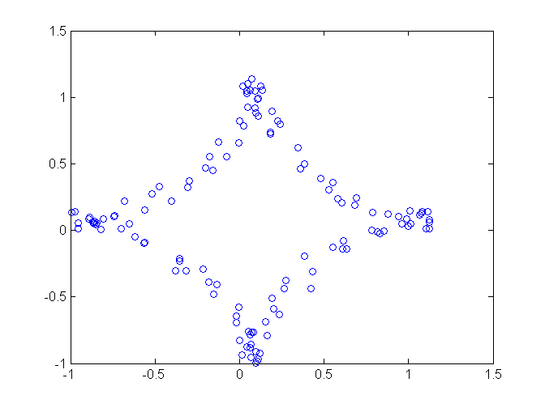

1. Let the data set HW1a.txt (see Dropbox 8-21-2017) be given. Try to use the least squares method with polynomial basis up to degree 3 to fit the data.

